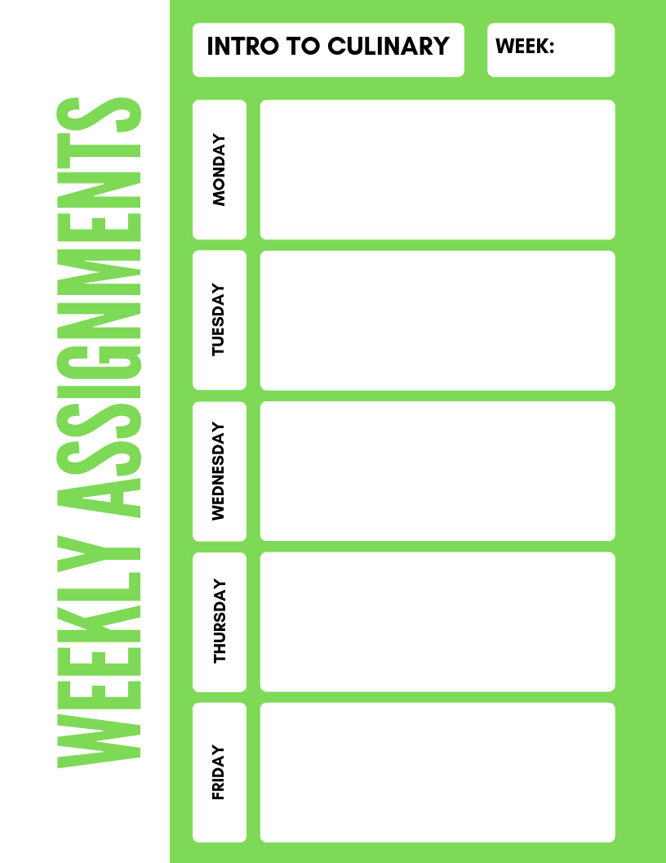

**Intro to Culinary**

**9**

Chef **Smith-** HANDS ON **LAB** Tomato Concasse/Medium Dice/Pico

Chef Boccaccio- Cooking Methods Word Scramble, Cooking Methods Unit Test

PSAT Day 8:20-12:20

1st Block and Hawk Hour only after testing

**EARLY RELEASE DAY**

Chef **Boccaccio-** HANDS ON **LAB** Tomato Concasse/Medium Dice/Pico

Chef Smith-Cooking Methods Word Scramble, Cooking Methods Unit Test

Chef **Smith**- HANDS ON **LAB** , *Batonnet of Potato/Mince Cilantro*

Chef Boccaccio- Cooking Methods T/F Quiz

Cooking Terms Wordsearch

Chef **Boccaccio** HANDS ON **LAB** ,*Batonnet of Potato/Mince Cilantro*

Chef Smith- Cooking Methods T/F Quiz and Cooking Terms Wordsearch