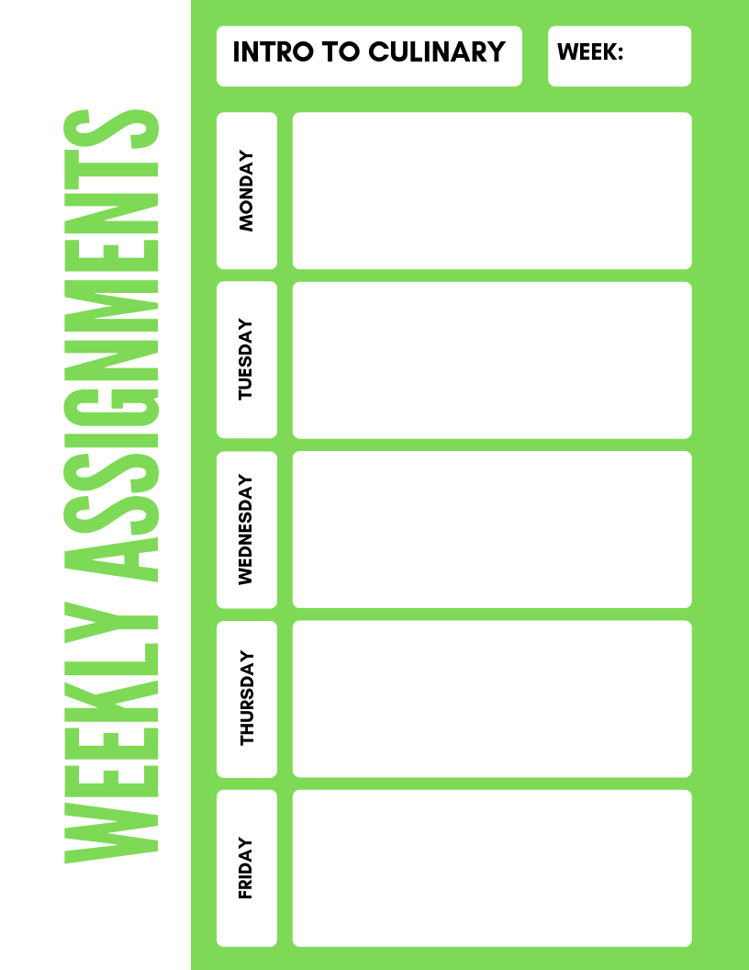

**Intro to Culinary**

**8**

Moist heat Cooking Notes Activity Sheet

-Moist Cooking Techniques Reading Activity 15.3 worksheet

Garlic Mash Potato and Small Dice Onion Lab

Dry Heat Cooking Methods Quiz Dry Heat Recipe Research Activity

Julienne Lab

Ch. 15.2 reading activities and Dry Heat XW