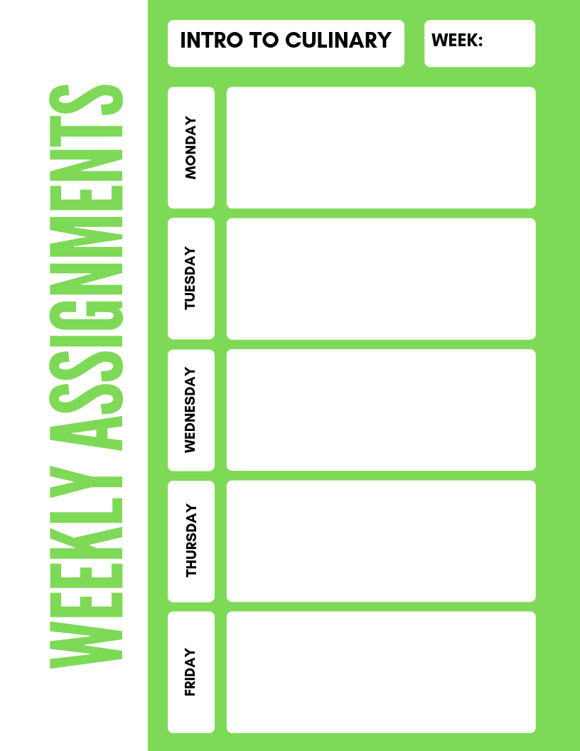

**Intro to Culinary**

**6**

**HHS Cafeteria Tour, wear closed toed shoes!**

***Equipment Search* quiz** and ***3.2 and 3.3 Equipment crossword puzzles***

***Large Equipment (Ch. 11) packet***

***11-1 Identifying Large Equipment***

***Snoop Doggie Lab*** activity

**Chp. 10.2 Reading Activity Smallwares**

***Equipment ID Test***

***Smallwares equipment and uses activity 2019***