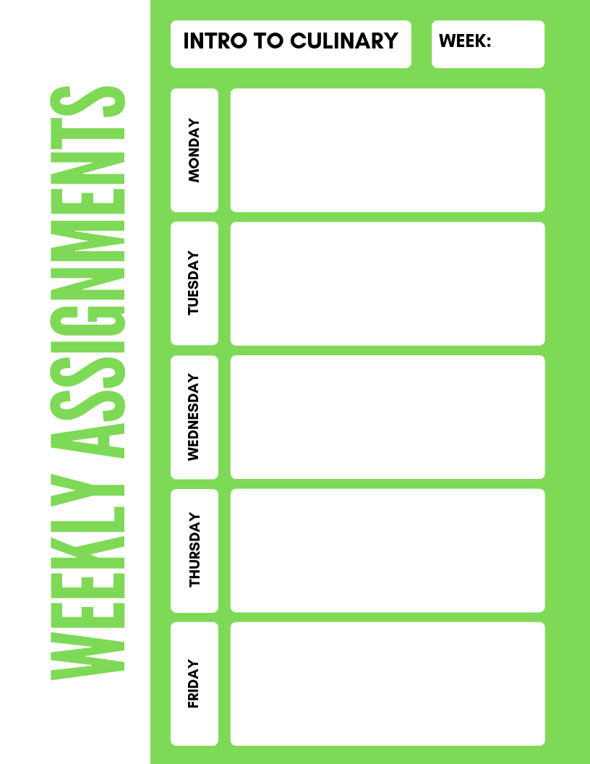

**Intro to Culinary**

**3**

**From video: Kitchen Safety What NOT to do- list 10 violations**

**Sign of Safety worksheet**

**Safety Basic Reading Activity 1.1**

**Sanitation Unit Test**

**3.1 Review Questions on page 172 of the red textbook**

***Play SS Jeopardy*** Game

***Chapter 1 food safety XW***

***Service Inspection video activity***

***Sanitation Scenarios 1 and 4.***