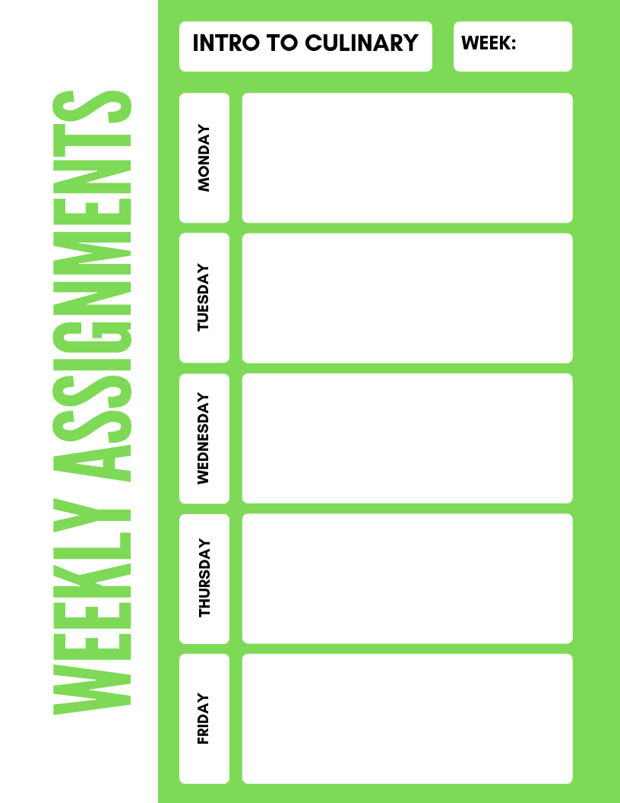

**Intro to Culinary**

**2**

**Preventing Food Spoilage Unscramble,**

**Sanitation Word Search,**

**Our Safety and Sanitation Story**

**Class Starters Foodborne Illness**

**Reading Activity 2.1 The Safe Food Handler**

**2.3 FATTOM fill in blank**

**Flow of Food XW Puzzle**

**Food Safety XWord puzzle**

“**What’s wrong with this picture”**