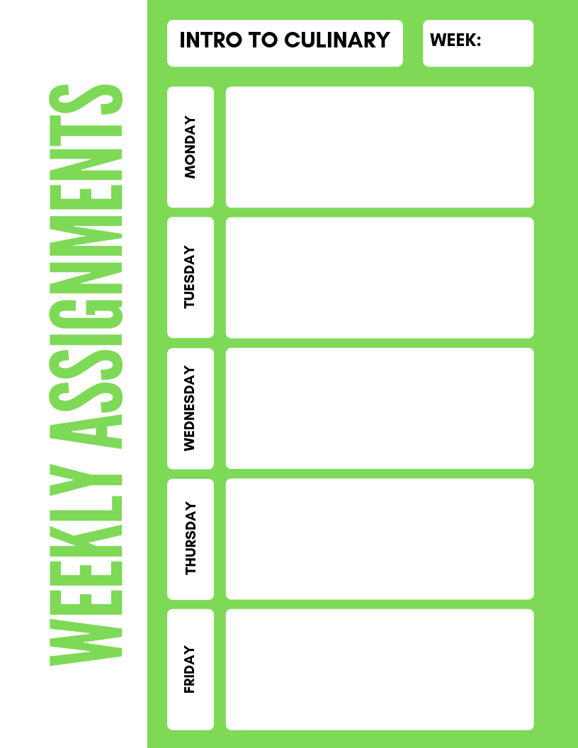

**Intro to Culinary**

**1**

-Pr**esent History of Culinary Arts project**

**-1 FACT for each historical figure presentation**

**-Kitchen Brigade XW**

**- History of Culinary Art Project (due Friday)**

**- History of Culinary Art Project (due Friday)**

**- online Culinary Arts SGM test**

**-Kitchen Brigade Matchin**g

- **History of Culinary Arts Project (due Friday)**

-**The Culinarians Code**