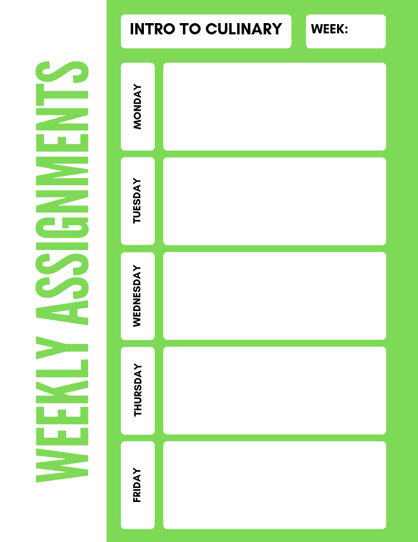

**SMITH- Grilled Chicken Lab**

**Intro to Culinary**

**12**

**BOCCACCIO- Grilled Chicken Lab** 100 vegetables You need to Know

Types of vegetables

Vegetable Activity and Crossword

Organic Veggies “I support position (A or B) using _______ article because ____________”

Organic Veggie Debate mini paper

Vegetable Classifications activity Vegetable Study Guide

Reading Activity 25 Vegetables Vegetable Word Search