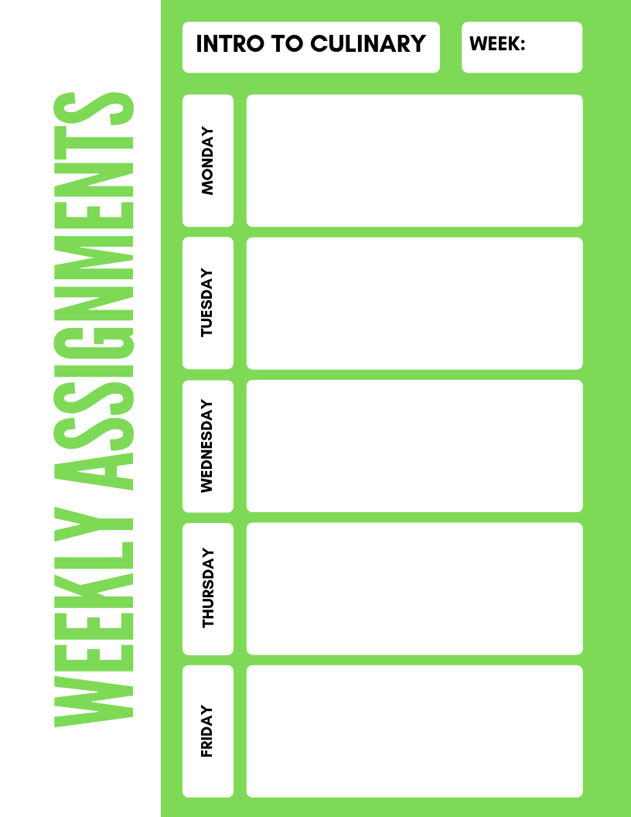

**Intro to Culinary**

**10**

Study Guide 5.1 Understanding Standardized recipes

Study Guide, “Altering Recipes”,

“Recipe Standardization/Culinary **Math Test.**

Conversion worksheets

4.8 recipe conversion

**PSAT Testing 1st and 2nd block**

**3rd and 4th block meets only**

4.7 Equivalents Measures

Chapter 2 Math Exercises

4.6 Mastering Measurement

Kitchen Equivalents

When you are Measuring